**SEMTA Breadboard Signal Processing**

Radar Breadboard Schematic:

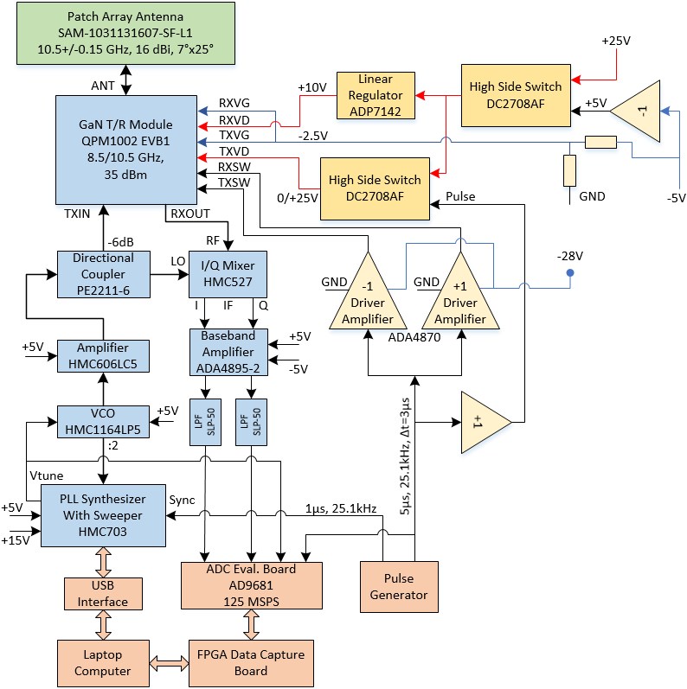

It’s pulsed type radar, which is based on chirp (linear frequency sweep) modulation waveform and applied extending processing to de-chirp the transmit signal in receiver. We plan to use 4 channels of the ADC to digitize: two I and Q radar baseband signals, transmit pulse, and ramp signal from PLL synthesizer. Baseband bandwidth is in 5-50MHz range, and DAC sampling is 125 MSPS. Ramp signal and two pulses from pulse generator are shown on pictures below.

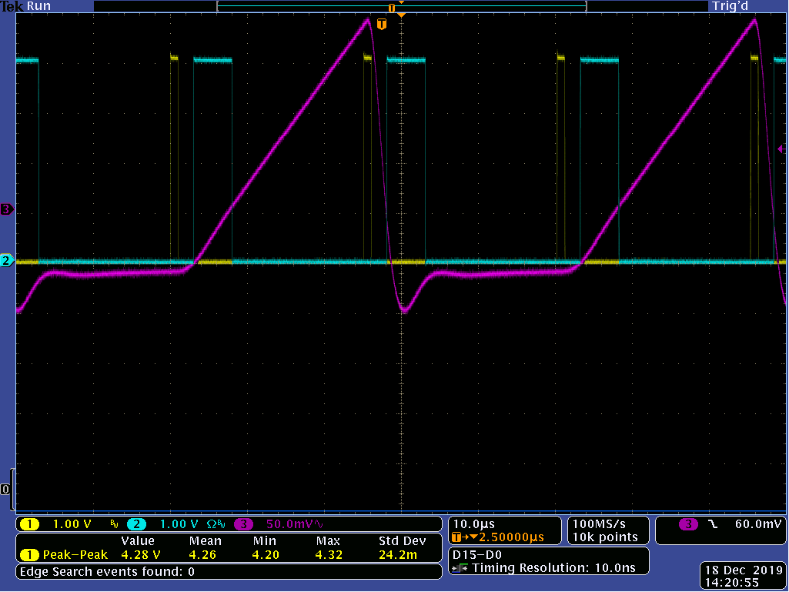

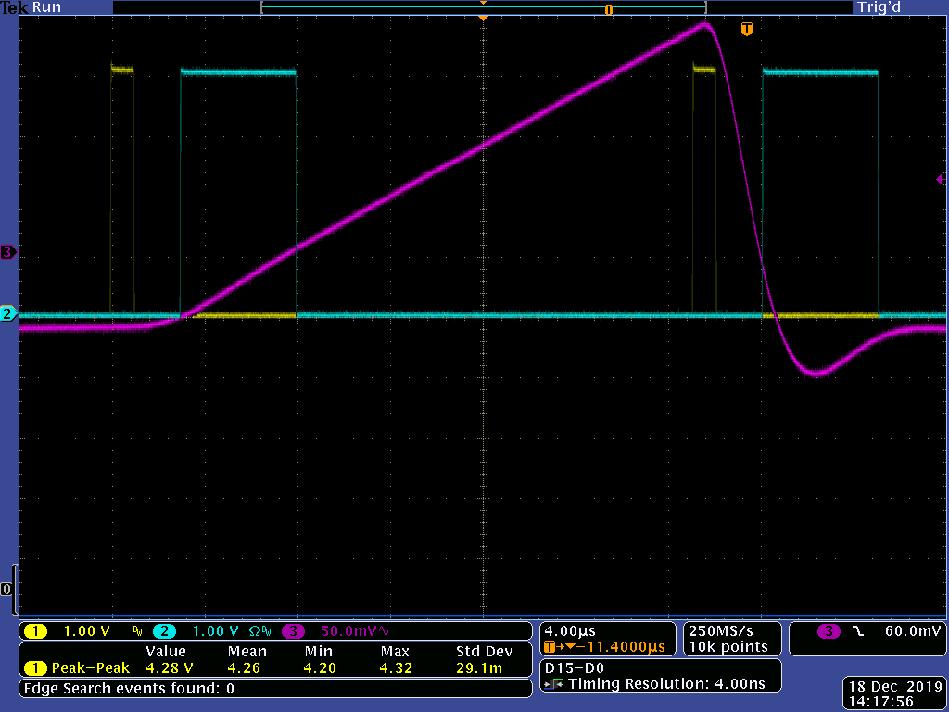

Yellow pulses serve to control PLL synthesizer. The PLL needs two control pulses: one to start frequency sweep, and second to return frequency back after the sweep complete. The sweep bandwidth is 50 MHz and its duration is 25µs. The control pulses have 1µs length and 39.8 kHz repletion frequency (PRF). The PRF is slightly less than 40 kHz to allow 25µs sweep. Chirp repetition rate is two times lower: 19.9 kHz. Blue 5-µs (10 MHz bandwidth) pulses turn radar transmitter on. Beyond the transmit pulse the radar is in receiver mode. The transmit pulses have the same PRF as PLL control pulses, but they are delayed in 3µs to fit with the PLL circuit delay. Only one of two transmit pulses – during the sweep - is useful for radar. Second pulse is idle as result of the current pulse generator limitation. The combination of ramp and transmit pulse signals allow to select useful pulse and ignore idle one.

As shown on the picture below, some distortions in the I and Q signals (red and blue) occur during transient time.

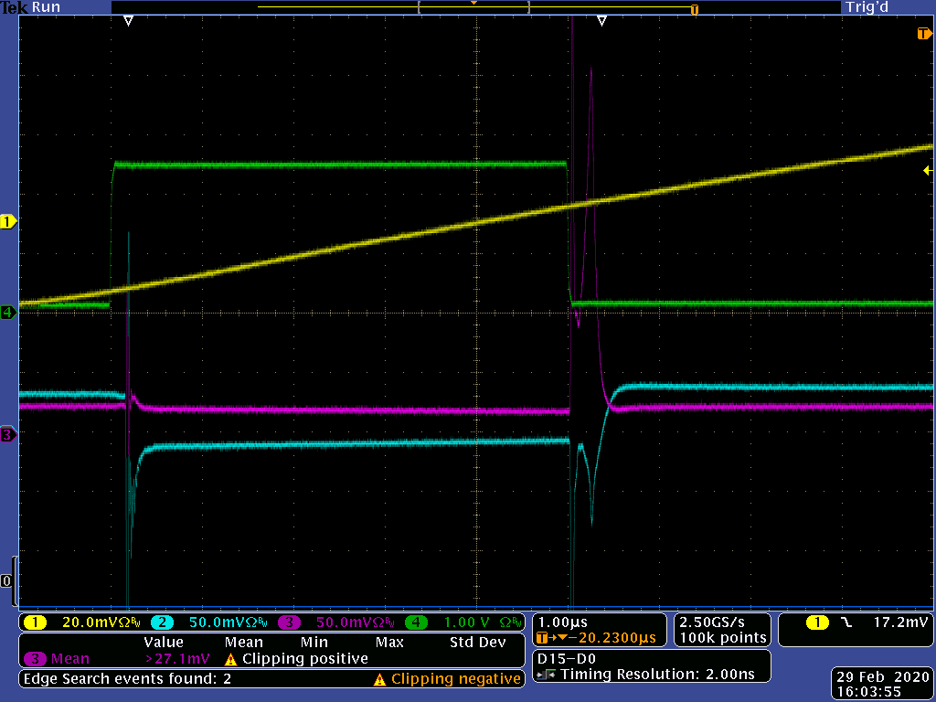

To avoid the distortion first point of the receive signal should be shift in 0.6µs (75 samples) after end of the transmit pulse, or with 5.6µs delay after its start. Last point of each chirp cycle should be at 23µs after the transmit pulse start. So, duration of single receive period has 17.4µs.

Total number of chirp cycles to be recorded and processed is 2048, which takes about 103ms. The radar signal processing is based on 2D FFT algorithm, similar as for fast FMCW radar. However, to avoid SNR degradation, first FFT operation should be implemented separately with several (supposedly with 5) time intervals. The length of each interval would be 7µs, and they would be shifted in 2.6µs from each other. Thus, if the start of the transmit pulse is 0µs on the time axis, the interval positions would be:

1. From 5.6 to 12.6 (µs),
2. From 8.2 to 15.2 (µs),
3. From 10.8 to 17.8 (µs),
4. From 13.4 to 20.4 (µs), and
5. From 16 to 23 (µs).

7µs interval takes 875 samples. 1024 points should be used for FFT. So, other 149 points are added as zero padding. No weighting function to apply, only rectangular 7µs window. After FFT, the rectangular windows in frequency domain would be applied. The windows are partially overlapped and would cover following frequency bands:

1. From 6 to 15.2 (MHz),
2. From 13.2 to 20.4 (MHz),
3. From 18.4 to 25.6 (MHz),
4. From 23.6 to 30.8 (MHz), and
5. From 28.8 to 38 (MHz).

Range to frequency coefficient is equal to 75 m/MHz. Thus, min range is 450m, and max range is 2850m. Range bin has 9.155m size. Total number of effective range bins is equal to 262 (or 263). Resulted complex values of the first FFT calculations in the five intervals should be put on single frequency (range) axis and summarize in the overlapping parts.

Second (velocity) FFT uses results of the 2048 chirps. Velocity bin size is 0.139 m/s, and measured velocity range +/-142.7 m/s. The measurement results should be presented on 3D magnitude/range/velocity graph.